Pandas and Seaborn (Advance Concepts)
Pandas
Pandas is a Python library used to load, clean, manipulate, analyze, and visualize structured data.
Python
Run
import pandas as pd
import numpy as np
import matplotlib.pyplot as plt
import seaborn as sns
Sample datasets
We'll create two DataFrames: one containing student information and another containing their exam scores.
Python
Run
students = pd.DataFrame({
"student_id": [1, 2, 3, 4, 5],
"name": ["Ali", "Sara", "Ahmed", "Ayesha", "Usman"],
"department": ["CS", "IT", "CS", "IT", "CS"],
"age": [20, 22, 21, 23, 25]
})

scores = pd.DataFrame({
"student_id": [1, 2, 3, 6],
"marks": [85, 90, 78, 88]
})

print(students)
print(scores)

1. Merging, Joining, and Concatenation
These operations combine multiple DataFrames into a single DataFrame.
- Merging: Combines data based on matching values in one or more columns.
- Joining: Combines DataFrames using their indexes by default.
- Concatenation: Stacks DataFrames vertically or horizontally.
1.1 Merging DataFrames
Pandas merge() works similarly to SQL joins.
Python
Run
pd.merge(
students,
scores,
on="student_id",
how="inner"
)
Here:
- students is the left DataFrame.
- scores is the right DataFrame.
- on="student_id" specifies the matching column.
- how="inner" specifies the type of join.
Four types of joins
A. Inner Join
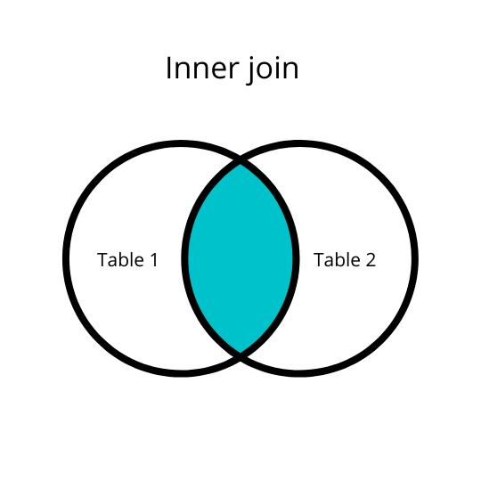
Meaning: Returns only rows whose keys exist in both DataFrames.
Python
Run
pd.merge(students, scores,
on="student_id", how="inner")
Student IDs 4 and 5 are missing from the scores table, and ID 6 is missing from the students table, so they are excluded.
B. Left Join
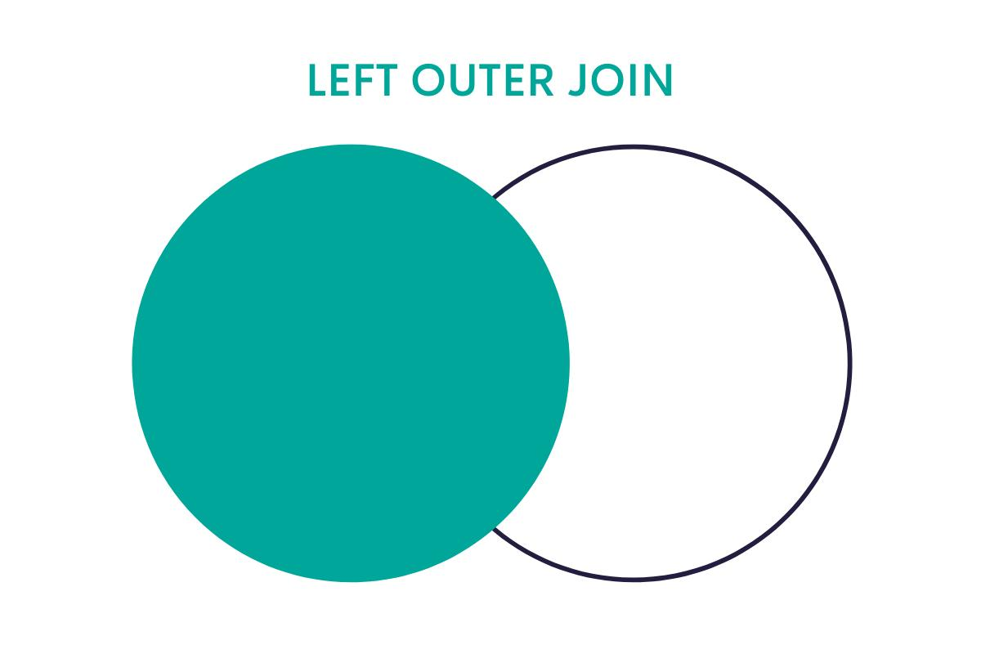
Meaning: Keeps every row from the left DataFrame and adds matching data from the right. Unmatched values become NaN.
Python
Run
pd.merge(students, scores,
on="student_id", how="left")
Use case: Keep all customers even if some have no recorded purchases.
C. Right Join
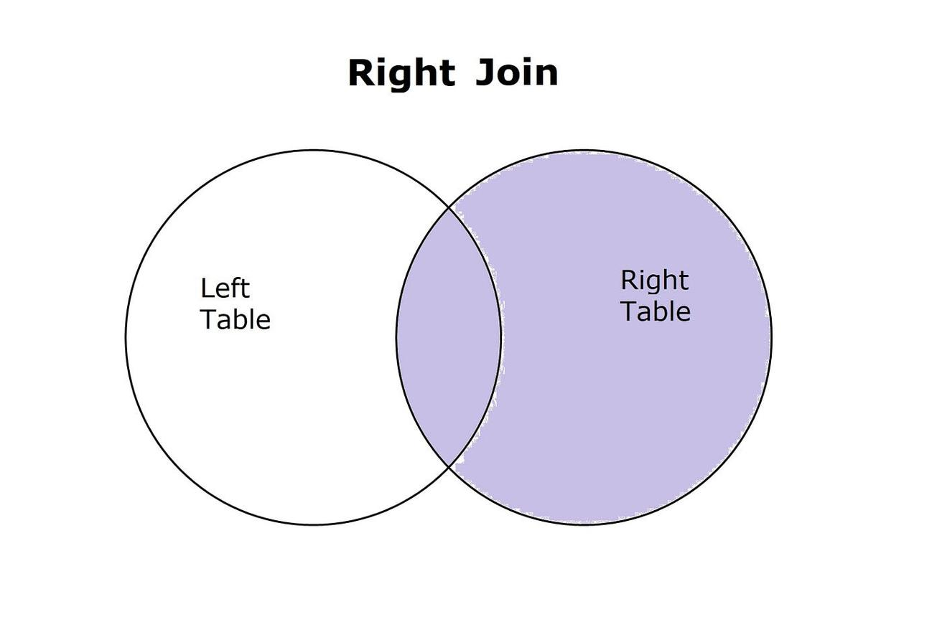
Meaning: Keeps every row from the right DataFrame and adds matching data from the left.
Python
Run
pd.merge(students, scores,
on="student_id", how="right")
Use case: Keep every exam score, even if a student record is missing.
D. Outer Join (Full Outer Join)
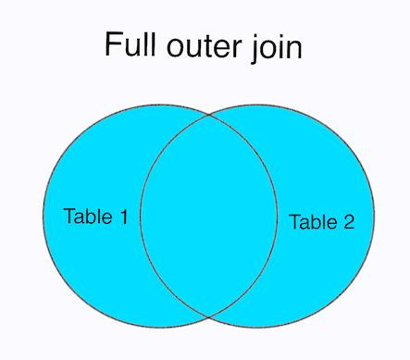
Meaning: Keeps all rows from both DataFrames. Unmatched values become NaN.
Python
Run
pd.mer2ge(students, scores,
on="student_id", how="outer")
Use case: Combine two datasets while retaining all records, including unmatched ones.
Merging on different column names
Python
Run
pd.merge(
students,
scores,
left_on="student_id",
right_on="student_id",
how="inner"
)
If the matching columns have different names, use left_on and right_on.
1.2 Joining DataFrames
Pandas join() combines DataFrames using their indexes by default.
Python
Run
students_indexed = students.set_index("student_id")
scores_indexed = scores.set_index("student_id")

result = students_indexed.join(
scores_indexed,
how="left"
)

print(result)
Result: All students remain in the output, and students without scores receive NaN.
Python
Run
# Join using indexes with an inner join
students_indexed.join(scores_indexed, how="inner")
Merge vs. Join
Main use | Match on columns (Merge) | Match on indexes(Join)
SQL-like | ✅ | Less so
Different key names | Combination based On Indexes | Like Sql join
Multiple Data Frames | merge() normally combines two at a time. | join() can combine several DataFrames in one call
Flexibility | Higher | Simpler for index-based work

1.3 Concatenation
pd.concat() combines DataFrames along rows or columns.
A. Vertical concatenation (row-wise)
Python
Run
df1 = pd.DataFrame({
"name": ["Ali", "Sara"],
"marks": [85, 90]
})
df2 = pd.DataFrame({
"name": ["Ahmed", "Ayesha"],
"marks": [78, 95]
})
result = pd.concat([df1, df2], axis=0, ignore_index=True)
axis=0 stacks rows, and ignore_index=True creates a fresh index.

B. Horizontal concatenation (column-wise)
Python
Run
left = pd.DataFrame({"name": ["Ali", "Sara"]})
right = pd.DataFrame({"marks": [85, 90]})

result = pd.concat([left, right], axis=1)
axis=1 places columns side by side, aligning rows by index.
Important: Concatenation does not match records by a key column like merge() does.
2. GroupBy in Pandas
groupby() is used to divide data into groups, perform calculations on each group, and combine the results.
This follows the Split–Apply–Combine process:
- Split: Divide the DataFrame into groups based on a column.
- Apply: Perform a calculation on each group.
- Combine: Return the results in a new Series or DataFrame.
Example dataset
Python
Run
df = pd.DataFrame({
"department": ["CS", "IT", "CS", "IT", "CS"],
"name": ["Ali", "Sara", "Ahmed", "Ayesha", "Usman"],
"marks": [85, 90, 78, 95, 88],
"age": [20, 22, 21, 23, 25]
})
2.1 Grouping by one column
Python
Run
df.groupby("department")["marks"].mean()
Output:
department
CS 83.67
IT 92.50
Explanation:
- CS students: 85, 78, 88 → average = 83.67
- IT students: 90, 95 → average = 92.5
2.2 Common GroupBy functions
|
Function
|
Purpose
|
| --- | --- |
|
mean()
|
Average
|
|
sum()
|
Total
|
|
count()
|
Number of non-null values
|
|
size()
|
Number of rows
|
|
min()
|
Minimum
|
|
max()
|
Maximum
|
|
median()
|
Middle value
|
|
std()
|
Standard deviation
|
|
nunique()
|
Number of unique values
|
Examples:
Python
Run
# Average marks by department
df.groupby("department")["marks"].mean()

# Total marks by department
df.groupby("department")["marks"].sum()

# Number of students in each department
df.groupby("department").size()

# Highest marks in each department
df.groupby("department")["marks"].max()
2.3 Multiple aggregations with agg()
You can calculate several statistics at once.
Python
Run
df.groupby("department")["marks"].agg(
["mean", "min", "max", "count"]
)
2.4 Grouping by multiple columns
Python
Run

This creates groups based on combinations of department and age.
2.5 Using transform()
transform() returns a result aligned with the original DataFrame's rows.
Python
Run
df["department_avg"] = (
df.groupby("department")["marks"].transform("mean")
)

print(df)
Each student receives the average marks of their department.
ML use case: Calculate group-level statistics such as average spending by customer segment, or average salary by department. When creating ML features, calculate these statistics using training data only to avoid data leakage.
3. Discretization and Binning
Discretization converts continuous numerical data into a limited number of categories or intervals.
Binning is the process of dividing numerical values into groups called bins.
Binning is useful for simplifying data, creating categories, and visualizing distributions.
3.1 Equal-width binning using pd.cut()
pd.cut() divides a numerical range into specified intervals.
Python
Run
ages = [18, 22, 27, 35, 45, 60, 75]

bins = [0, 20, 40, 60, 100]

labels = ["Young", "Adult", "Middle-aged", "Senior"]

age_groups = pd.cut(
ages,
bins=bins,
labels=labels
)

print(age_groups)
Output:
['Young', 'Adult', 'Adult', 'Adult',
'Middle-aged', 'Middle-aged', 'Senior']
By default, pd.cut() uses right-closed intervals. For example, (20, 40] includes values greater than 20 and up to 40.
Add bins to a DataFrame
Python
Run
df = pd.DataFrame({
"name": ["Ali", "Sara", "Ahmed", "Ayesha"],
"age": [18, 25, 42, 65]
})

df["age_group"] = pd.cut(
df["age"],
bins=[0, 20, 40, 60, 100],
labels=["Young", "Adult", "Middle-aged", "Senior"]
)
3.2 Equal-frequency binning using pd.qcut()
pd.qcut() divides data into groups based on quantiles, aiming to place approximately equal numbers of observations in each group.
Python
Run
scores = [10, 20, 30, 40, 50, 60, 70, 80]

pd.qcut(
scores,
q=4,
labels=["Q1", "Q2", "Q3", "Q4"])
This creates four groups corresponding to quartiles.
ML example: Convert customer income into low, medium, and high income groups, or divide customers into spending quartiles. Binning can lose information, so it should be used when categories are meaningful for the task.
4. Operations on DataFrames
Pandas provides many operations for changing, filtering, sorting, and analyzing data.
4.1 Selecting columns
Python
Run
df["name"] # One column
df[["name", "age"]] # Multiple columns
4.2 Selecting rows with loc and iloc
Python
Run
df.loc[0] # Row with index label 0
df.iloc[0] # First row by position

df.loc[0:2] # Index labels 0 through 2
df.iloc[0:2] # First two rows
loc uses labels, while iloc uses integer positions.
4.3 Filtering rows
Python
Run
df[df["age"] > 25]
Multiple conditions:
Python
Run
df[(df["age"] > 20) & (df["marks"] >= 80)]
Use & for AND and | for OR, with parentheses around each condition.
4.4 Adding and updating columns
Python
Run
df["passed"] = df["marks"] >= 50

df["bonus_marks"] = df["marks"] + 5
4.5 Deleting columns and rows
Python
Run
df.drop(columns=["bonus_marks"], inplace=True)

df.drop(index=0, inplace=True)
Without inplace=True, drop() returns a new DataFrame and leaves the original unchanged.
4.6 Sorting
Python
Run
df.sort_values("marks", ascending=False)
Sort by multiple columns:
Python
Run
df.sort_values(
["department", "marks"],
ascending=[True, False]
)
4.7 Handling missing values
Python
Run
df.isna().sum() # Count missing values
df.dropna() # Remove rows with missing values
df.fillna(0) # Replace missing values with 0
df["marks"].fillna(df["marks"].mean()) # Fill with mean
4.8 Applying functions
Python
Run
df["marks_doubled"] = df["marks"].apply(lambda x: x * 2)
Use apply() when you need to apply a function to values in a Series or along a DataFrame axis. For simple arithmetic, vectorized operations are usually more efficient.
4.9 Renaming columns
Python
Run
df.rename(
columns={"marks": "exam_marks"},
inplace=True
)
4.10 Removing duplicate rows
Python
Run
df.drop_duplicates()
You can also specify columns:
Python
Run
df.drop_duplicates(subset=["name"])
5. Data Output and Saving
Pandas can export DataFrames to CSV, Excel, JSON, and other formats.
5.1 Save to CSV
Python
Run
df.to_csv("students.csv", index=False)
- to_csv() writes the DataFrame to a CSV file.
- index=False prevents saving the DataFrame's index as an extra column.
Read it back:
Python
Run
df = pd.read_csv("students.csv")
5.2 Save to Excel
Python
Run
df.to_excel("students.xlsx", index=False)
Read it:
Python
Run
df = pd.read_excel("students.xlsx")
Excel support generally requires openpyxl for .xlsx files.
5.3 Save to JSON
Python
Run
df.to_json("students.json", orient="records", indent=4)
Read it:
Python
Run
df = pd.read_json("students.json")
5.4 Save to a text file
Python
Run
df.to_csv("students.txt", sep="\t", index=False)
This creates a tab-separated text file.
5.5 Other useful output methods
Method | Purpose
to_csv() | CSV file
to_excel() | Excel file
to_json() | JSON file
to_html() | HTML table
to_pickle() | Python object serialization
to_parquet() | Efficient columnar storage

6. Pandas for Plotting
Pandas has built-in plotting methods based on Matplotlib. You can create visualizations directly from a Series or DataFrame using .plot().
Example dataset:
Python
Run
df = pd.DataFrame({
"month": ["Jan", "Feb", "Mar", "Apr", "May"],
"sales": [100, 150, 130, 200, 250],
"profit": [20, 35, 25, 50, 70]
})
Most plotting examples below use df.plot() or df.plot.<kind>().
6.1 Area plot
Shows how values change over time, with the area below the line filled.
Python
Run

df.plot(
x="month",
y="sales",
kind="area"
)

plt.show()
Use case: Visualize cumulative trends in sales or revenue.
6.2 Bar plot
Displays values using vertical bars.
Python
Run
df.plot(
x="month",
y="sales",
kind="bar"
)

plt.show()
Use case: Compare monthly sales.
6.3 Horizontal bar plot (barh)
Displays horizontal bars.
In Python Run:
df.plot(
x="month",
y="sales",
kind="barh")
plt.show()
Use case: Compare categories with long labels.
6.4 Line plot
Shows trends and changes over an ordered variable.
Python
Run
df.plot(
x="month",
y="sales",
kind="line",
marker="o"
)

plt.show()
Use case: Track monthly sales or stock prices over time.
6.5 Histogram (hist)
Shows the frequency distribution of numerical data.
Python
Run
df["sales"].plot(
kind="hist",
bins=5
)

plt.show()
Use case: Understand how values are distributed.
6.6 Density plot (density)
Displays a smoothed estimate of a numerical distribution.
Python
Run
df["sales"].plot(kind="density")

plt.show()
This is similar to a KDE plot.
6.7 KDE plot
KDE stands for Kernel Density Estimation. In Pandas, kind="kde" is an alias for density plotting.
Python
Run
df["sales"].plot(kind="kde")
plt.show()
Use case: Understand the shape of a continuous distribution.
6.8 Scatter plot
Shows the relationship between two numerical variables.
Python
Run
df.plot(
x="sales",
y="profit",
kind="scatter"
)

plt.show()
Use case: Explore whether higher sales are associated with higher profits.
6.9 Box plot
Displays the median, quartiles, and potential outliers.
Python
Run
df[["sales", "profit"]].plot(kind="box")

plt.show()
Use case: Identify unusual values and compare distributions.
6.10 Hexbin plot
A hexbin plot divides a two-dimensional space into hexagonal bins and colors each bin according to the number of observations.
Python
Run
df.plot(
x="sales",
y="profit",
kind="hexbin",
gridsize=10
)
plt.show()
Use case: Visualize dense relationships between two numerical variables, especially with large datasets.
6.11 Pie chart
Shows proportions of a whole.
In Python Run:
df.plot(
x="month",
y="sales",
kind="pie",
labels=df["month"],
legend=False
)
plt.show()
Use case: Display the share of total sales contributed by each category. Pie charts work best with a small number of categories.
Pandas plotting summary
Pandas plotting summary
Plot | Main purpose
area | Filled trend
bar | Compare categories
barh | Horizontal comparison
line | Trends over ordered values
hist | Frequency distribution
density / kde | Smoothed distribution
scatter | Relationship between two variables
box | Spread and outliers
hexbin | Density of two numerical variables
pie | Proportions of a whole

Part 2: Introduction to Seaborn
7. What is Seaborn?
Seaborn is a Python data visualization library built on top of Matplotlib. It makes it easier to create attractive statistical plots and explore relationships in datasets.
Seaborn is especially useful in Data Science and Machine Learning for:
- Understanding numerical distributions.
- Comparing categories.
- Finding correlations between features.
- Identifying outliers.
- Exploring relationships between features and targets.
Import Seaborn
Python
Run
import seaborn as sns
import matplotlib.pyplot as plt
import pandas as pd

sns.set_theme(style="whitegrid")
Create a sample dataset
Python
Run
df = pd.DataFrame({
"department": ["CS", "IT", "CS", "IT", "CS",
"IT", "CS", "IT"],
"gender": ["M", "F", "M", "F", "F", "M", "M", "F"],
"marks": [85, 90, 78, 95, 88, 70, 92, 82],
"hours": [4, 6, 3, 7, 5, 2, 6, 4],
"age": [20, 22, 21, 23, 25, 24, 22, 21]
})
Seaborn uses the data parameter to accept a DataFrame and column names for x and y.
For example:
Python Run
sns.scatterplot(
data=df,
x="hours",
y="marks"
)
plt.show()
This displays the relationship between study hours and marks.
8. Distribution Plots
Distribution plots help us understand how numerical values are spread across a dataset.
They can reveal:
- Central tendency.
- Spread and variability.
- Skewness.
- Multiple peaks.
- Potential outliers.
Seaborn's modern distribution plotting tools include histplot(), kdeplot(), rugplot(), displot(), and jointplot().

seaborn 0.13.2 documentation
+1
8.1 distplot() — Distribution plot
distplot() was a legacy Seaborn function used to display a histogram, KDE curve, and optionally a rug plot together.
Python
Run
sns.distplot(df["marks"])

plt.show()
Important: distplot() is deprecated and has been removed from newer Seaborn versions. Use histplot() or displot() instead.
seaborn 0.13.2 documentation
+1
Modern replacement
Python
Run
sns.histplot(
data=df,
x="marks",
kde=True
)

plt.show()
This creates a histogram with a smooth density curve.
8.2 jointplot() — Joint distribution
jointplot() displays the relationship between two numerical variables, along with their individual distributions on the margins.
Python
Run
sns.jointplot(
data=df,
x="hours",
y="marks",
kind="scatter"
)
plt.show()
It displays:
- A scatter plot in the center.
- A distribution of study hours at the top.
- A distribution of marks on the side.
Common kind options
Python
Run
# Scatter plot
sns.jointplot(data=df, x="hours", y="marks", kind="scatter")

# Density contours
sns.jointplot(data=df, x="hours", y="marks", kind="kde")

# Hexagonal bins
sns.jointplot(data=df, x="hours", y="marks", kind="hex")
ML use case: Explore the relationship between a feature such as study hours and a target such as marks.
8.3 pairplot() — Pairwise relationships
pairplot() creates a grid of plots showing relationships between multiple numerical variables.
Python
Run
sns.pairplot(
df,
vars=["marks", "hours", "age"],
hue="department"
)

plt.show()
It produces:
- Scatter plots for pairs of numerical variables.
- Distribution plots along the diagonal.
- Different colors for each department.
ML use case: Explore relationships among features before training a model.
Note: Pairplots can become slow and cluttered when you have many features.
8.4 rugplot() — Individual observations
A rug plot displays small marks along an axis, with each mark representing one observation.
Python
Run
sns.rugplot(
data=df,
x="marks"
)

plt.show()
You can also combine it with a histogram:
Python
Run
sns.histplot(data=df, x="marks", kde=True)
sns.rugplot(data=df, x="marks")

plt.show()
Use case: See the individual observations behind a distribution.
8.5 kdeplot() — Kernel Density Estimation
A KDE plot estimates a smooth probability density curve for numerical data.
Python
Run
sns.kdeplot(
data=df,
x="marks",
fill=True
)

plt.show()
Bivariate KDE
Python
Run
sns.kdeplot(
data=df,
x="hours",
y="marks",
fill=True
)

plt.show()
This shows regions where observations are concentrated.
Important: A KDE curve is an estimate, not the exact distribution. It can be misleading with very small datasets or discrete data.
9. Categorical Data Plots
Categorical plots help compare numerical values across groups, or count the frequency of categories.
For example:
- Compare average marks across departments.
- Compare salary distributions across job titles.
- Count customers in different product categories.
Seaborn organizes categorical visualizations into scatter plots, distribution plots, and estimate plots.
seaborn 0.13.2 documentation
+1
9.1 factorplot() — Legacy categorical plotting function
factorplot() was the older figure-level interface for categorical plots.
Python
Run
sns.factorplot(
data=df,
x="department",
y="marks",
kind="box"
)
Important: factorplot() was renamed to catplot(). Use catplot() in modern Seaborn versions.
seaborn 0.11.2 documentation
+1
Modern replacement
Python
Run
sns.catplot(
data=df,
x="department",
y="marks",
kind="box"
)
The kind parameter determines the categorical plot type.
9.2 boxplot() — Box plot
A box plot summarizes the distribution of a numerical variable across categories.
Python
Run
sns.boxplot(
data=df,
x="department",
y="marks"
)
plt.show()
A box plot shows:
- Median: the middle value.
- Box: the interquartile range (Q1 to Q3).
- Whiskers: the range determined by the box plot's rule.
- Individual points beyond the whiskers: potential outliers.
ML use case: Compare the distribution of salaries across job categories or identify unusual values in different groups.
9.3 violinplot() — Violin plot
A violin plot combines a density shape with a central summary of the distribution.
Python
Run
sns.violinplot(
data=df,
x="department",
y="marks"
)
plt.show()
The width of the violin represents the estimated density at different values.
Difference from boxplot: A box plot emphasizes quartiles and median; a violin plot emphasizes the distribution's shape.
Use case: Compare the shape of salary distributions across departments.
9.4 stripplot() — Categorical scatter plot
A strip plot displays individual observations for each category.
Python
Run
sns.stripplot(
data=df,
x="department",
y="marks",
jitter=True
)
plt.show()
jitter=True spreads points slightly to reduce overlap.
Use case: View the actual marks of individual students in each department.
9.5 swarmplot() — Non-overlapping categorical scatter plot
A swarm plot spreads points within each category so they do not overlap, when space allows.
Python
Run
sns.swarmplot(
data=df,
x="department",
y="marks"
)
plt.show()
Difference from stripplot:
- Strip plot uses jitter to reduce overlap.
- Swarm plot adjusts point positions to avoid overlap more systematically.
Use case: Display individual observations in small or medium-sized datasets. Swarm plots can become slow for large datasets.
9.6 barplot() — Statistical bar plot
A Seaborn bar plot displays a statistical estimate of a numerical variable for each category. By default, it shows the mean and an uncertainty interval.
Python
Run
sns.barplot(
data=df,
x="department",
y="marks"
)

plt.show()
This compares average marks across departments.
Change the estimator
Python
Run
sns.barplot(
data=df,
x="department",
y="marks",
estimator="median",
errorbar=None
)

plt.show()
Use case: Compare average salary, average sales, or average exam marks across categories.
Important: A Seaborn barplot() is different from a count plot. It summarizes a numerical variable rather than simply counting observations.
9.7 countplot() — Category frequency
A count plot displays the number of observations in each category.
Python
Run
sns.countplot(
data=df,
x="department"
)
plt.show()
This counts the number of students in each department.
Count by two categories
Python
Run
sns.countplot(
data=df,
x="department",
hue="gender"
)

plt.show()
This compares the number of male and female students within each department.
ML use case: Check class imbalance in a classification dataset, such as the number of customers who churned versus those who did not.
Categorical plots comparison
Plot | What it shows
boxplot() | Median, quartiles, potential outliers
violinplot() | Distribution shape and density
stripplot() | Individual observations with jitter
swarmplot() | Individual observations with reduced overlap
barplot() | Statistical estimate, usually mean
countplot() | Number of observations per category
catplot() | Figure-level interface for categorical plots

10. Matrix Plots: Heatmap
10.1 What is a heatmap?
A heatmap is a visualization that represents numerical values using colors in a matrix.
Different colors or shades indicate different numerical values.
Heatmaps are especially useful for:
- Correlation matrices.
- Feature relationships in ML.
- Missing-value patterns.
- Comparing values across rows and columns.
10.2 Basic heatmap
Python
Run
data = pd.DataFrame(
[[10, 20, 30],
[40, 50, 60],
[70, 80, 90]],
index=["A", "B", "C"],
columns=["X", "Y", "Z"]
)

sns.heatmap(
data,
annot=True,
cmap="coolwarm"
)

plt.show()
Explanation:
- annot=True displays numerical values inside cells.
- cmap="coolwarm" selects a color palette.
- Rows and columns form the matrix.
10.3 Correlation heatmap
One of the most common uses in ML is to visualize correlations between numerical features.
Python
Run
correlation = df[["marks", "hours", "age"]].corr()

sns.heatmap(
correlation,
annot=True,
cmap="coolwarm",
vmin=-1,
vmax=1
)

plt.show()
Understanding correlation values
Correlation | Meaning
Close to +1 | Strong positive linear relationship
Close to 0 | Weak or no linear relationship
Close to -1 | Strong negative linear relationship
For example, a correlation of 0.85 between study hours and marks suggests a strong positive linear association.
Important: Correlation does not prove causation. A correlation near zero also does not rule out a nonlinear relationship.
11. Important: Older vs. Modern Seaborn Functions
Some functions in your syllabus are from older Seaborn versions. Here are their modern alternatives.
Older function | Modern alternative
distplot() | histplot() or displot()
factorplot() | catplot()
jointplot() | Still supported
pairplot() | Still supported
rugplot() | Still supported
kdeplot() | Still supported
Seaborn's modern API uses displot() for figure-level distribution plots and catplot() for figure-level categorical plots.

12. Practical Machine Learning Workflow
Here's how these Pandas and Seaborn concepts fit into a typical ML project.
- Load data
python df = pd.read_csv("data.csv")
- Clean and prepare data
Handle missing values, duplicates, and incorrect data types.
- Combine datasets
Use merge(), join(), or concat() as appropriate.
- Analyze groups
Use groupby() to calculate averages, counts, and other statistics.
- Create categories
Use pd.cut() or pd.qcut() when numerical values need meaningful bins.
- Explore visually
Use histograms, box plots, scatter plots, pairplots, and correlation heatmaps.
- Save the prepared data
python df.to_csv("cleaned_data.csv", index=False)
- Prepare features and target
Separate input features (X) from the target (y) before training a model.
Key takeaways
- Pandas is primarily for data manipulation and analysis.
- Merge and join combine related datasets; concat stacks data along rows or columns.
- GroupBy calculates statistics for groups.
- Binning converts numerical values into categories.
- Pandas plotting provides quick visualizations through Matplotlib.
- Seaborn provides statistical plots for distributions, categories, and feature relationships.
- Heatmaps are particularly useful for exploring correlations between numerical features.
Official documentation
- Pandas: Merging, joining, and concatenation
- Pandas: GroupBy guide
- Pandas: Visualization guide
- Seaborn: Distribution plots
- Seaborn: Categorical plots

